CSD 330 – Security Analytics

Bid #2

Kabir Kanha Arora

Topic: Real-Time Crime Reporting using interactive Map application
(Type 1 – Self Chosen)

Synopsis
Interactive & user-friendly map application for the public to inform nearby police stations and PCR vans about the crimes and emergencies in real time. The map also shows locations of crimes and emergencies happening around the user in real-time. An additional feature is that the live location of PCR vans nearby will be available on the app so that the user can reach out to it in case of an emergency. An SOS alarm and a SOS flashlight pattern will also be flashed as an additional optional feature. The location and an SOS message are also sent to emergency contacts.

Connection to this course
Perhaps this is not directly connected to cybersecurity, but I still feel it definitely falls into the purview of Security Analytics, which is defined as the process of using data collection, aggregation, and analysis tools for security monitoring and threat detection.
This is something that is hugely relevant in the Indian context today and is a topic that is genuinely very close to my heart, and one that I would dearly like to work on.
This is a very practical problem so instead of doing literature review, I have done a careful market research to compare apps and services that currently exist in the market to solve this problem.

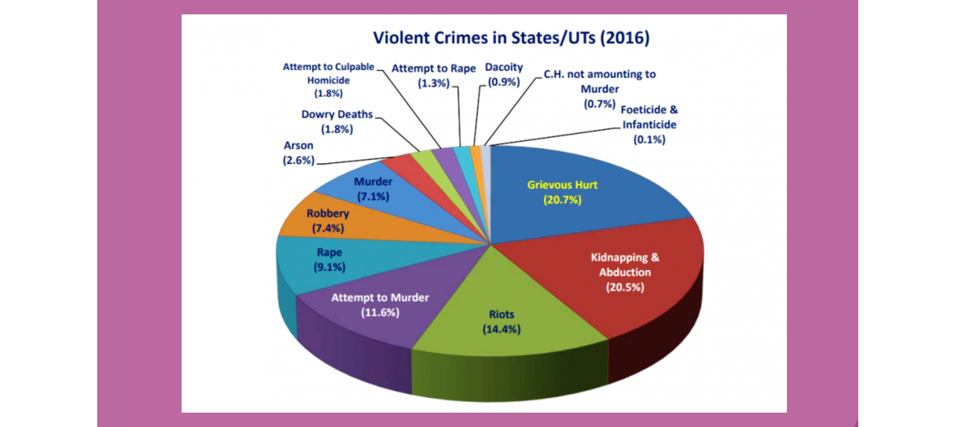

Why?
- Increasing crime rate in India.
- Help not reaching in time.
- No facility which helps stop crime while its happening.
- A number of unreported cases.

Features
- Real time map showing crimes reported around us on the app.
- Police patrol cars will have their locations pinned to the map.
- Nearby police station and nearby police PCR vans notified on the press of a button.
- Three buttons for three different purposes – SOS, Report, Caution.
- Distraction Button
- Voice/Shortcut Activation
- Medical details stored for emergency purposes.

Potential Users
- Numerous crimes, including theft, kidnapping, robbery and sexual assaults can be prevented using the app.
- Since this can happen to anyone at any time, the potential user base is pretty much anyone and everyone.

Assumption
- For the purpose of explanation, I assume that once this app comes into the market, every police station and patrol vehicle has it and they constantly monitor it.

SOS Button
If a person thinks that they are in grave danger, they can send out an S.O.S in which case the app sends out a broadcast to the 10 closest people, the chosen emergency contacts, the nearest police patrol vahicles and the police stations. While the app allows people to share their live locations, to counter any internet issues, the broadcast sends their static location via coordinates in an SMS.

Caution Button
Upon clicking this button, the app automatically sends their live location to the emergency contacts and also informs the user about the location of the nearest police station and PCR van.

Report Button
If any user chooses to report a crime, the app automatically sends the details to the nearest police station and PCR van. It also allows users to share multimedia attachments and the crime details would become visible on the app for anyone to see and help.

Scalability
After initial beta testing, the app can be launched across the country and later worldwide.

User Experience
While the app promises a plethora of features, the UI will be kept easy to use as the app needs to be usable in times of extreme distress. The UI will allow the user to easily identify what he/she wished to do, thus saving time at a crucial point.

Market Analysis
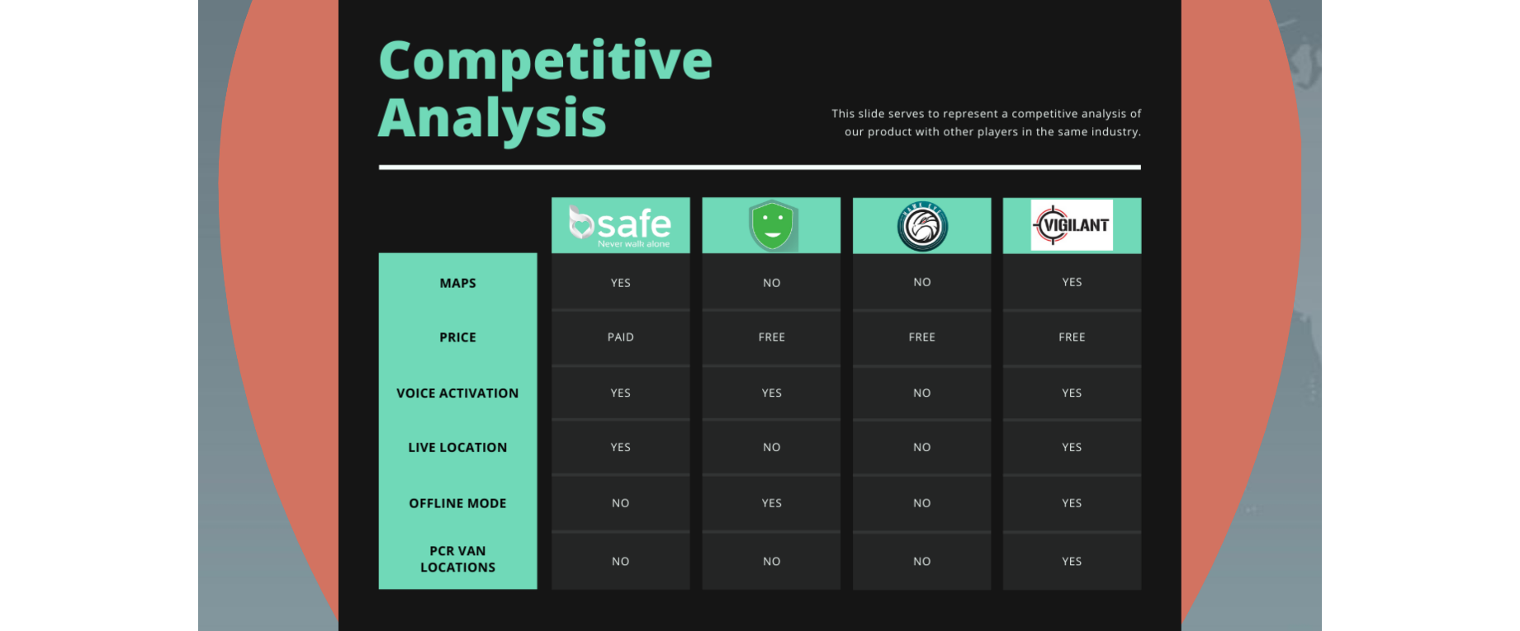
None of the apps that are available have all these features.

Scope for using ML Models
- K-Means clustering algorithm (Unsupervised) can be used to detect fake alerts and suspend suspicious accounts.
- Regression analysis (Supervised) can be used to decide the optimal placement of PCR vans to prevent crime before it happens.
Note: Given our limited knowledge of ML, considering that only one class has happened till now for the same, this is all I could come up with since we have not had any prior exposure. Obviously as I start to build the project, I will be using far better and detailed models.

